Geometry (Pappus configuration)
Name
Institution of Affiliation
Course Code
Date
Geometry (Pappus configuration)
Exercise 1
In the proof of Pappus theorem, we have silently assumed that the (yellow) Menelaus triangle is non-degenerate, i.e. that the three vertices are not collinear. Show that this follows if we assume that the two lines through 𝑝1, 𝑝2, 𝑝3 and 𝑞1, 𝑞2, 𝑞3 are distinct.
In this question, we need to show that the vertices of a triangle are not collinear as indicated by the Menelaus triangle.
We have been given two lines running through distinct points 𝑝1, 𝑝2, 𝑝3 and 𝑞1, 𝑞2, 𝑞3.
For lines to be collinear, they must lie on the same plane.
The distinct lines can be plotted to give △p1q1q3 with p2 and q2 cutting inside the triangle and p3 cutting outside as shown below.
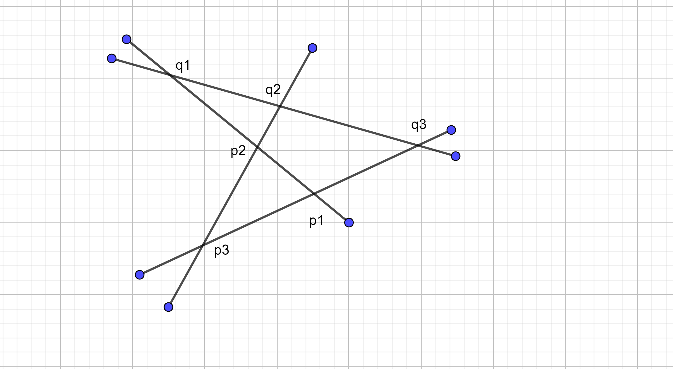
The lines will only be collinear if $\frac{p2q1}{p1q1}$ · $\frac{q1q2}{q3q2}$ · $\frac{q3q1}{p3p1}$ = 1
We choose p1 as the origin of the affine plane f2 and thus can treat f2 as a vector space.
Then,
p1, p2 and p1, p3 can be basic vectors of f2.
Thus, we can abbreviate ap1, p2+bp1p3 as $\left(\begin{aligned}a \\ b\end{aligned}\right)$.
By assumption,
q1 = $\frac{1}{1+q1}$(𝑃1 + q1𝑃2) = $\frac{1}{1+q1}\left[\begin{aligned}q1 \\ 0\end{aligned}\right]$
q2 = $\frac{1}{1+q2}$ (𝑃2 + q2𝑃3) = $\frac{1}{1+q2}$ $\left(\begin{aligned}1 \\ q2\end{aligned}\right)$
q3 = $\frac{1}{1+q3}$ (𝑃3 + q3𝑃1) = $\frac{1}{1+q3}$ $\left(\begin{aligned}0 \\ 1\end{aligned}\right)$
The lines are collinear if and only if their determinant is zero, which can be tested as follows:
Det = $\begin{matrix}\frac{q1}{1+q1} & \frac{1}{1+q1} & 0 \\ 0 & \frac{q2}{1+q2} & \frac{1}{1+q3} \\ 1 & 1 & 1\end{matrix}$
As 𝜏𝑖𝑗 ≠ −1, we can multiply each column by the appropriate 𝜏𝑖𝑗 to clear the denominators without losing the test for being zero.
However, for the test of zero to hold, the following chain of equalities must hold for some k ∈ R:

k³∗q1q2=k²∗q2q3 = k∗q3q1 = q1q2
Since the lines are distinct, the only way the first equation can hold is if k is a root of x²+x+1. This polynomial does not have any real roots, and thus the two lines cannot be collinear.
Exercise 2
Let 𝑝1, 𝑝2, 𝑝3 and 𝑞1, 𝑞2, 𝑞3 be six distinct points in the affine plane ℝ 2. Assume that the lines 𝑝𝑖 𝑞𝑗 and 𝑝𝑗 𝑞𝑖 meet in three distinct points 𝑡𝑖𝑗 for all pairs 1 ≤ 𝑖 < 𝑗 ≤ 3. Show that if 𝑝1, 𝑝2, 𝑝3 and 𝑡12, 𝑡23, 𝑡13 are both collinear, then also 𝑞1, 𝑞2, 𝑞3 are collinear.
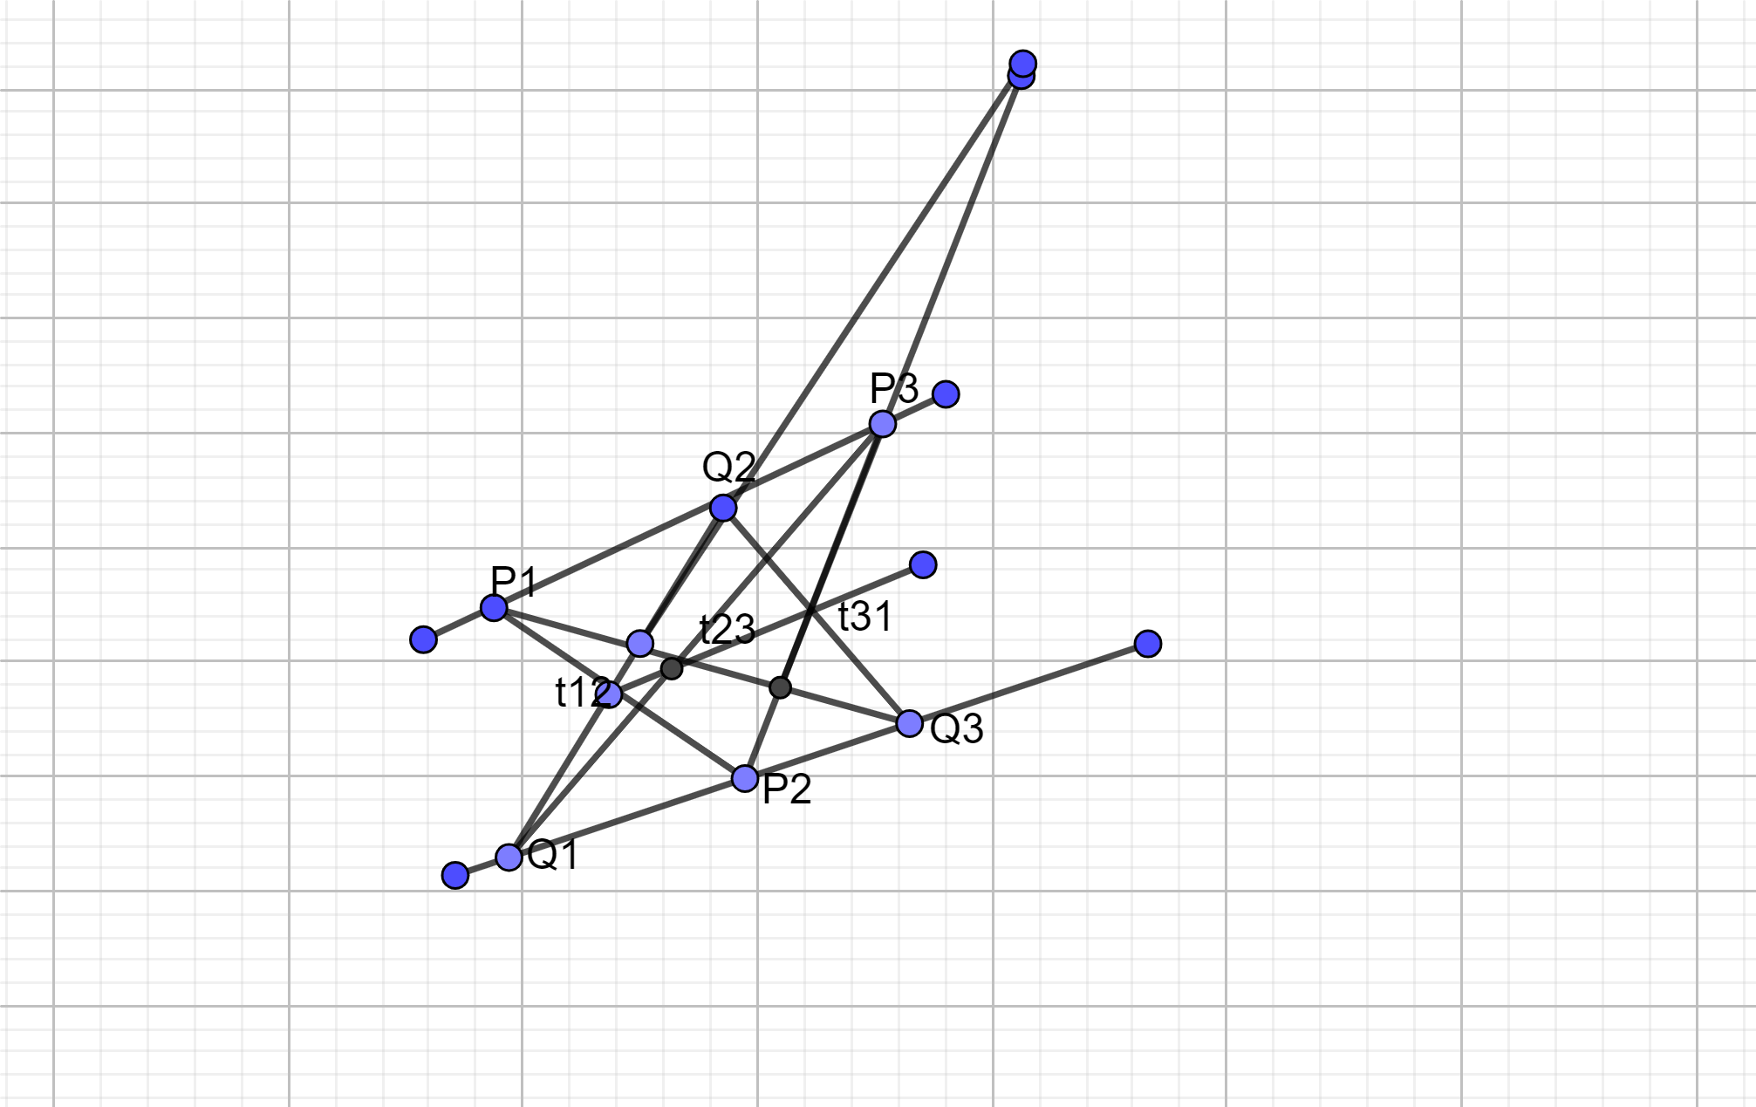
The six points 𝑇12, 𝑇23, 𝑇31 are collinear if and only if T₁₂ ·T₂₃·T₃₁ = -1.
We have to show that 𝑇₁₂, 𝑇₂₃ and 𝑇₃₁ /p1, p2, p2/q1, q2, q3 are collinear. Denote the dilation of 𝔽2 with center at 𝑇𝑖𝑗 that maps to 𝑃𝑗.
We can choose 𝑃1𝑃2 and 𝑃1𝑃3 as the basis vectors
Then,
q1 = 1 1 + q1 (𝑃1 + q1𝑃2) = 1 1 + q1 $\left[\begin{aligned}q1 \\ 0\end{aligned}\right]$
q2 = 1 1 + q2(𝑃2 + q2𝑃3) = 1 1 + q2 $\left(\begin{aligned}1 \\ q2\end{aligned}\right)$
q3 = 1 1 + q3 (𝑃3 + q3𝑃1) = 1 1 + q3 $\left(\begin{aligned}0 \\ 1\end{aligned}\right)$
Det = $\begin{matrix}\frac{q1}{1+q1} & \frac{1}{1+q1} & 0 \\ 0 & \frac{q2}{1+q2} & \frac{1}{1+q3} \\ 1 & 1 & 1\end{matrix}$
Det = 0
As 𝜏𝑖𝑗 ≠ −1, we can multiply each column by the appropriate 𝜏𝑖𝑗 to clear the denominators without losing the test for being zero, and obtain
Det =$\begin{matrix}q1 & 1 & 0 \\ 0 & q1 & 1 \\ 1+q1 & 1+q2 & 1+q3\end{matrix}$
$$Det=\begin{matrix}q1 & 1 & 0 \\ 0 & q2 & 1 \\ 1 & 0 & q3\end{matrix}$$
Based on this solution,
(t₁₂q₁ / q₂t₁₂) / (t₂₃p₃ / t₂₃q₁) / (t₃₁p₃ /t₃₁p₂) = 1
Therefore, if p1p2p3 and 𝑡12, 𝑡23, 𝑡13 are collinear then q1q2q3 must also be collinear.
Exercise 3
The following puzzle is played on the set of points ℤ 2 with integer coordinates in ℝ 2. The red points 𝑝1 = (0, 0), 𝑝2 = (1, −1), and 𝑝3 = (−2, 1) are ‘mirrors’, and the player has a blue peg placed on some point. A move consists of jumping with the peg across any of the three mirrors. For instance, if the peg is at the point (1, 0), we can jump to (−1, 0), (1, −2), or (5, 2), depending on which mirror we use. Find a sequence of jumps that takes a peg at position (1, 0) to position (1, 2) that is different from the solution below.
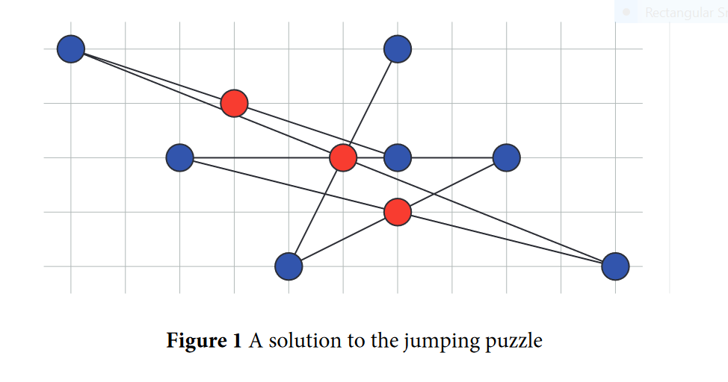

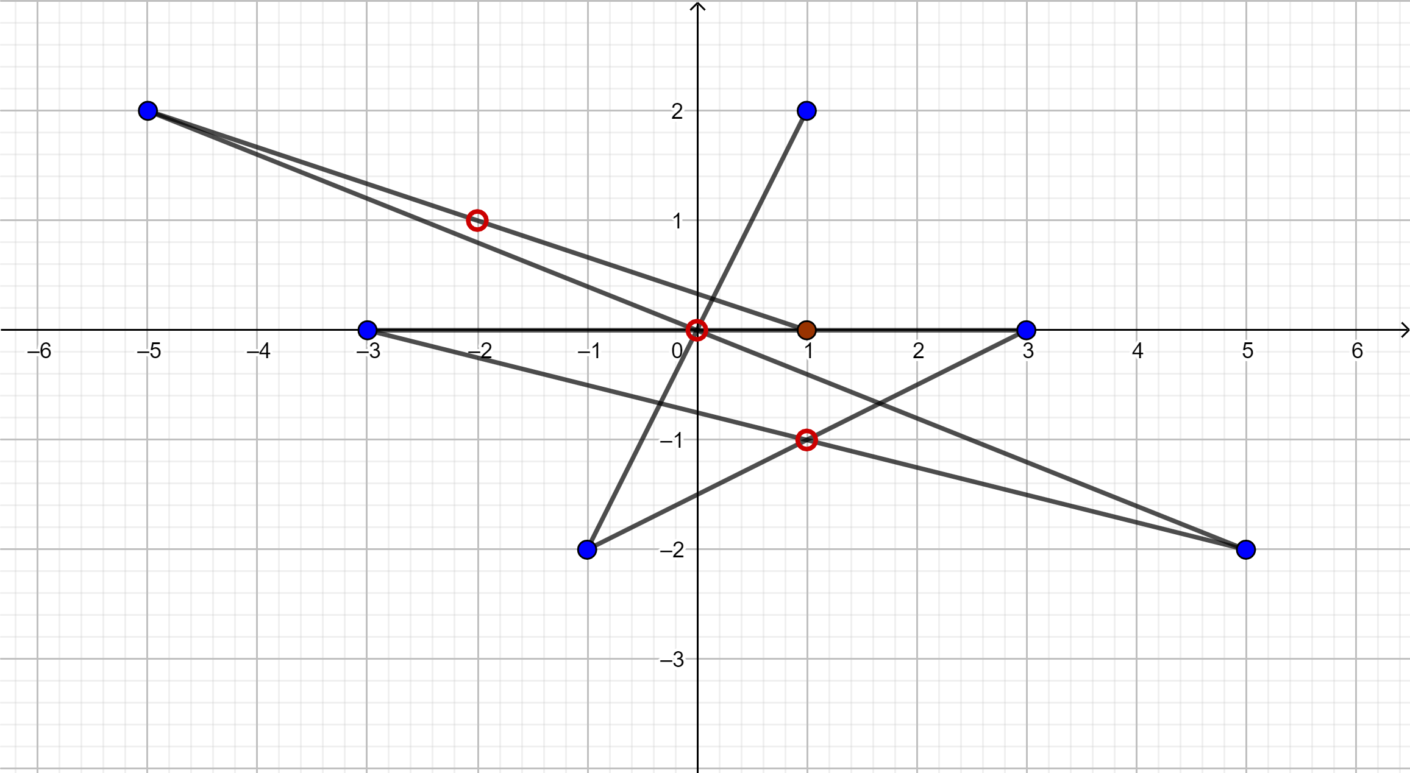
Using the mirrors in p1(0,0), p2(1, -1), p3(-2,1) from the first position we had the jumps as follows:
- P1(-5,2)
- P2(5, -2)
- P3(-3,0)
- P4(3,0)
- P5(-1, -2)
- P6(1,2)
Exercise 4
In this exercise, you will ‘design’ a Pappus configuration with the six points on two horizontal lines, and the line of the intersections a vertical line. Let 𝑝1, 𝑝2, 𝑝3 be three distinct points on the line 𝑦 = −1 and 𝑞1, 𝑞2, 𝑞3 be three distinct points on the line 𝑦 = +1 in the affine (𝑥, 𝑦)-plane ℝ 2. Assume that 𝑝1 = (2, −1). The lines 𝑝𝑖 𝑞𝑗 and 𝑝𝑗 𝑞𝑖 meet in three distinct points 𝑡𝑖𝑗 for all pairs 1 ≤ 𝑖 < 𝑗 ≤ 3. Locate the points 𝑝2, 𝑝3 and 𝑞1, 𝑞2, 𝑞3 such that 𝑡12 = (0, 3), 𝑡13 = (0, −3) and 𝑡23 = (0, 0).
